Required practical activity: Microscopy
Required Practical Guide – Microscopy

Aim: To use a light microscope to observe, draw and label biological specimens

Notes and guidance
Discuss this practical with your technician colleague in advance to see what pre-made microscopy slides are available.

Pre-made microscopy slides can be purchased from most school science suppliers. If possible, invest in a variety of these to spark the interest of students interested in different aspects of biology.

If pre-made slides are not available or if you wish students to conduct a longer practical, they can make their own slides to study. A good candidate for this is using iodine to stain onion skin. Further details can be found in the ‘alternative methods’ section below.

Your school’s microscopes may differ to those described here. The easiest for school use are those with built-in lights which can be recharged, however many must be plugged in or have a mirror instead of a lamp. Adapt the method accordingly.

Risk Assessment Notes
A risk assessment must be completed for this practical. The risk assessment should be specific to the class involved and written only by the teaching member of staff. For more guidance refer to CLEAPSS. It is good practice for students to wear safety spectacles during all class practicals and demos.

Any broken glass slides must be reported to the teacher and immediately swept up and disposed of in a sharps waste bin.

Equipment Per Group | 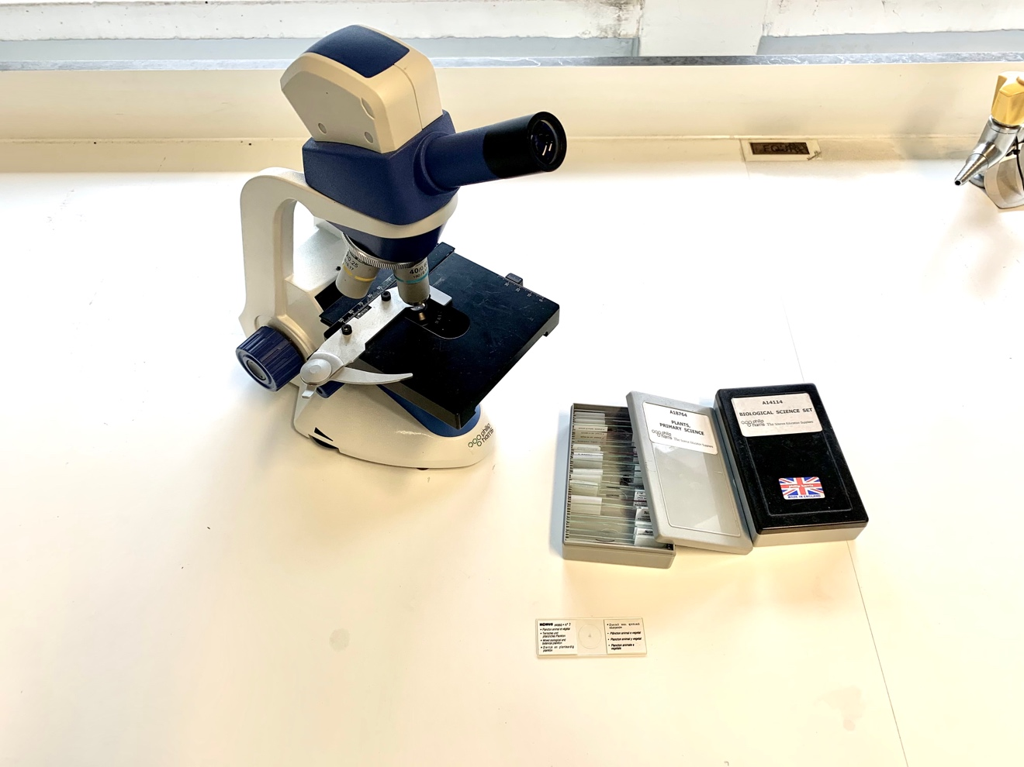
Apparatus:
- Microscope
- Selection of pre-made slides
- Pencil and paper for drawing

Method |  | Questions To Ask Students During The Practical
- Select a slide of cells and place it on the microscope’s stage.  - Rotate the nose piece until the lowest power objective lens is pointing down at the stage. This is usually the x4 objective lens.  - Without looking through the eyepiece yet, turn the course adjustment knob until the lens is almost touching the slide.  - Look through the eyepiece and turn rotate the course adjustment knob slowly to increase the distance between the lens and the slide. Stop when the cells come into focus. A typical eyepiece lens x10 magnification combined with a x4 objective lens would result in a x40 magnification.  - Use the fine adjustment knob to bring the slide into focus.  - Move the slide until you find a good group of cells, then rotate the nose piece to switch to a higher power objective lens. These are usually x10 and x40 magnification, resulting in a total of 100x and 400x magnification.  - Again, use the fine adjustment knob to bring the cells into focus.  - Using a pencil, make a clear and labelled drawing of what you can see. All component parts of the cell should be drawn and labelled.  - Multiply the objective magnification by the eyepiece magnification to find the total magnification. Write this underneath your drawing.  - Do the above for both animal and plant cells. |  | - Are the higher magnification lenses longer or shorter than the lower magnification lenses? (Higher magnification lenses are [usually] longer than lower magnification lenses.)  - Why are higher magnification lenses usually longer than lower magnification lenses? (They have a longer focal length. [A full explanation of focal lengths and lenses is not necessary for GCSE, and lens designs can vary, but it is useful for students to become more familiar with the microscopes and lenses they are using by paying attention to such physical characeristics.)  - What is the magnificaiton of the eyepice lens? (x10 – on most school microscopes.)  - What is the magnification of the objective lenses? (x4, x10, x40 – on most school microscopes.)  - Why do we start with the slide close to the lens and then lower it until it is in focus? (To do so the other way around would risk pushing the slide up into the lens, which could cause damage.)  - If a microscope had an eyepiece lens of x10 magnification and an objective lens of x100 magnification, what would be the total magnificaiton? (x1000 magnification.)  - Why do we use a pencil for scientific drawings? (It is neater than a pen and mistakes can be corrected.)
Clearing up
It is important that equipment is returned to the prep room in good order. If safe to do so, rinse used equipment and put it in the used equipment tray. If the trays arrived on a trolley, students must return all trays and equipment to that trolley. Anything dirty needs to be placed into a separate container for washing up. Never put dirty equipment back into a tray with clean equipment.
Alternative Methods/Computer Simulations
If pre-made slides are not available or if you wish to conduct a longer practical, they can make their own slides to study. A good candidate for this is using iodine to stain onion skin. Supply each group with a small piece of onion, tweezers, a white tile, paper towel, iodine, slide, and cover slip.

- Use the tweezers to remove the skin from the onion piece (smaller than cover slip).
- Place the onion skin on the slide on the white tile.
- Carefully add a small drop of iodine.
- Use the paper towel to soak up any excess iodine.
- Carefully press the cover slip down onto the onion skin (cover slips are very delicate – take care).

It is important to warn students of the hazards of broken glass and iodine. Cover slips must be handled carefully, and any iodine spills on tables or skin must be reported and cleaned up immediately. Iodine stains can be remedied with sodium thiosulfate solution. Stubborn stains will fade over time.
Technician Notes
Discuss this practical with the class teacher ahead of time. Ensure they have considered the risks of this practical and are confident with the techniques and equipment used. If they wish to use iodine to stain onion cells, provide them with the CLEAPSS hazcard (identified in the risk section section above) so they are comfortable with the chemical and how to use and dispose of it safely.

Count the pre-made slides before and after the lesson and encourage the teacher to do so also. Slides are easily broken or lost.

